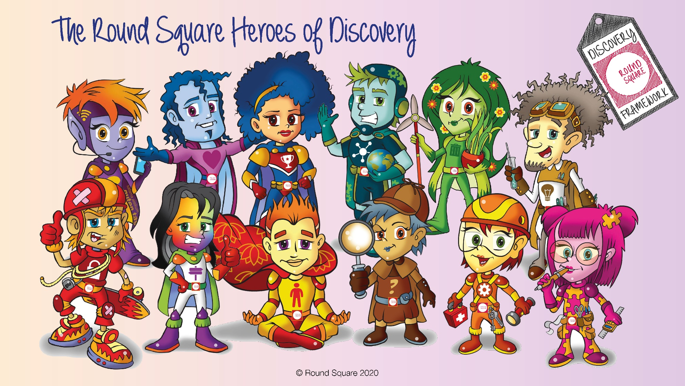

**Round Square Heroes of Discovery**